Workhorse Printer
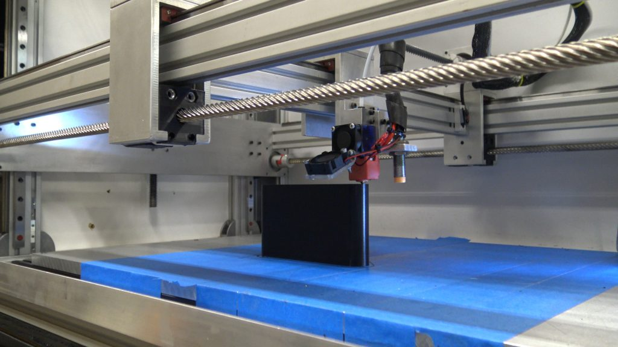WorkHorse Printer

The Workhorse Printer is a large format, open source 3d printer released by 3D Distributed in 2018. The printer is a modular machine platform that uses lead screw driven motion with a fixed bed / moving gantry.
- Fixed Bed / Moving Gantry
- X and Y-Axis Lead Screw
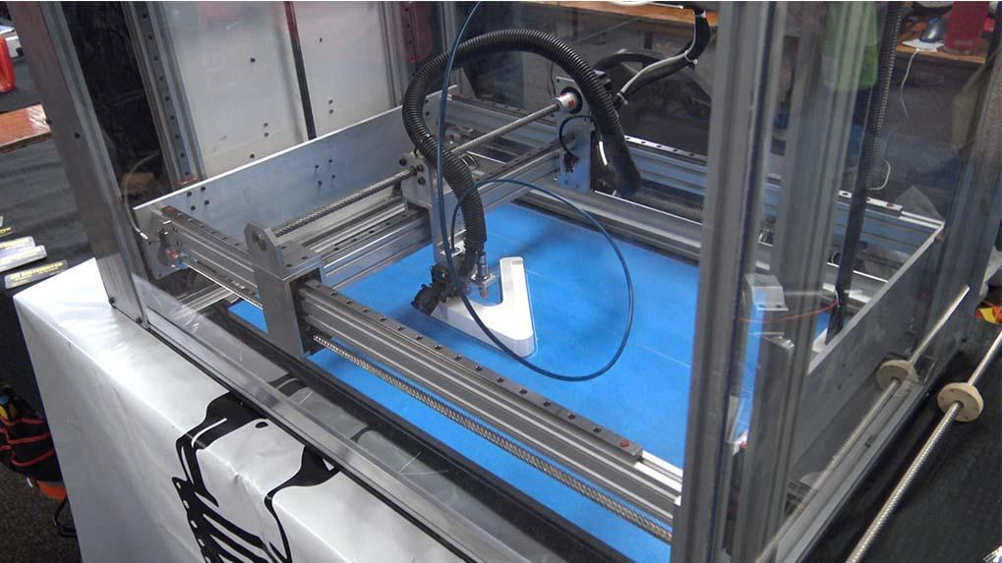

Most 3d printers use belt driven motion in the x and y axis to increase print speed but loses quality when more weight is applied to the gantry or carriage. The lead screw used on the Workhorse has a high helix pitch with multiple threads to allow increased print speeds while maintaining the quality provided from lead screw and ball screw motion.The robust and rigid system is particularly useful in applications that add more weight to the gantry or carriage. Materials such as clay, chocolate, plastic pellet extrusion or other foods can increase weight that is moved around which results in decreased quality or print speeds. Workhorse Printer’s are available to purchase in a Machined Component Kit, Hardware Kit or Complete Kit.
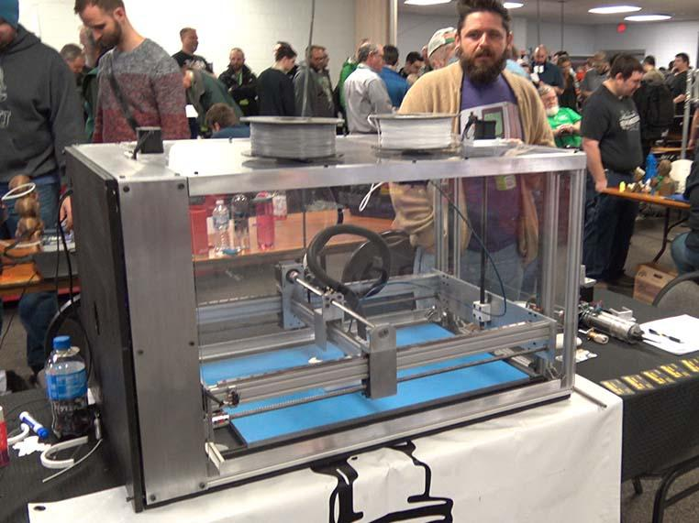Workhorse 3D Printer MRRF 2019

- OPEN SOURCE
- LARGE BUILD VOLUME
- ADVANCED LEAD SCREW MOTION
- MODULAR MACHINE DESIGN
- CUSTOM MODS
- CUSTOM BUILDS
- ENCLOSURE
- HEATED BED

Carriage
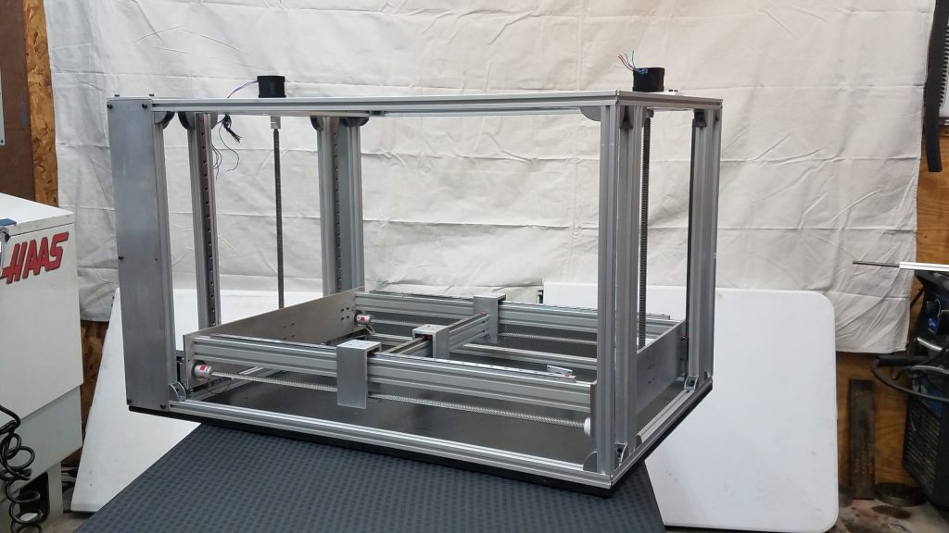Large 3D Printer Kit

The Workhorse Printer’s C-Carriage design is a robust solution for lead screw driven motion that uses linear rails and 20×40 or 20×20 aluminum extrusions.
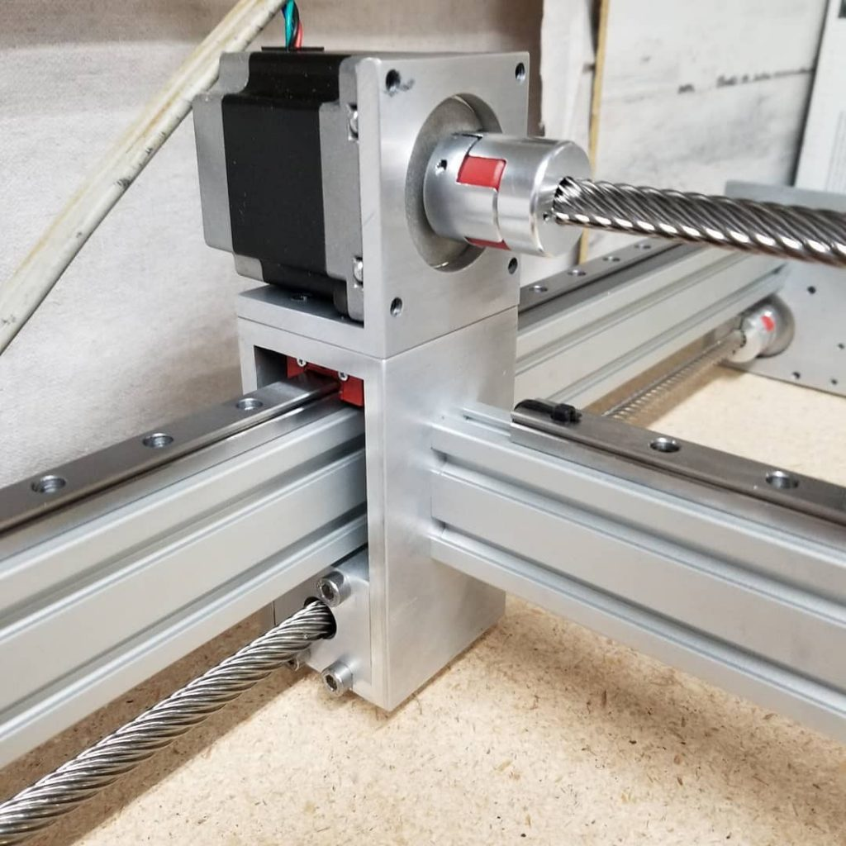WorkHorse Carriage

The Workhorse 3d printer is available with custom mods and upgrades. We’ve several custom designed machines for many of our customers. If there is a specific size or requirement you just give us a shout.

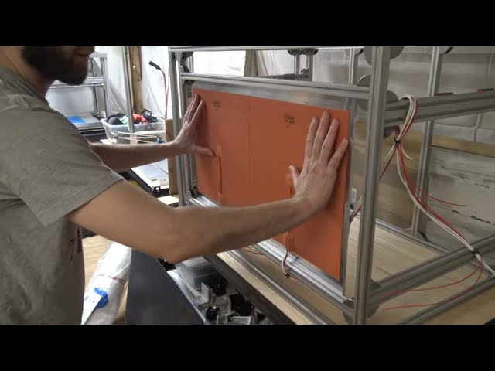

New Heated Bed

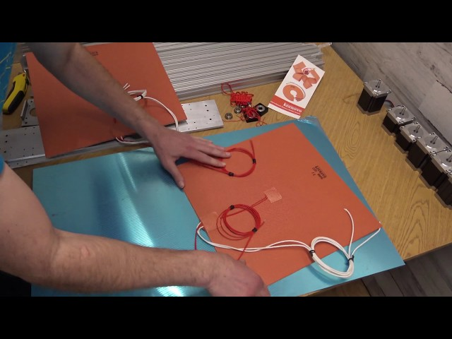

WorkHorse Printer Updates

Download Files

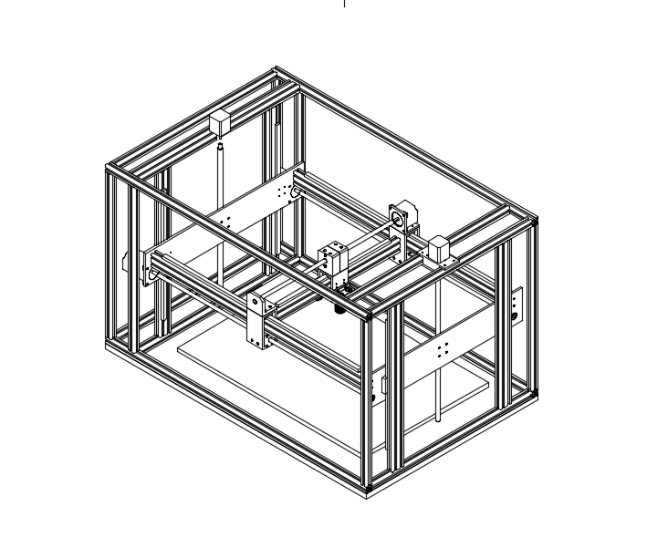WorkHorse Printer CAD

Thingiverse Files

3D Distributed Parts
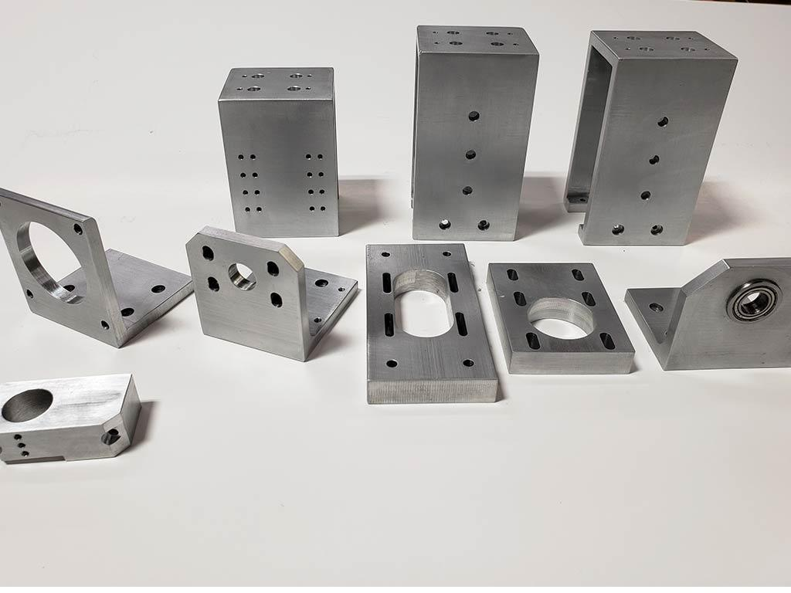WorkHorse 3D Printer Parts
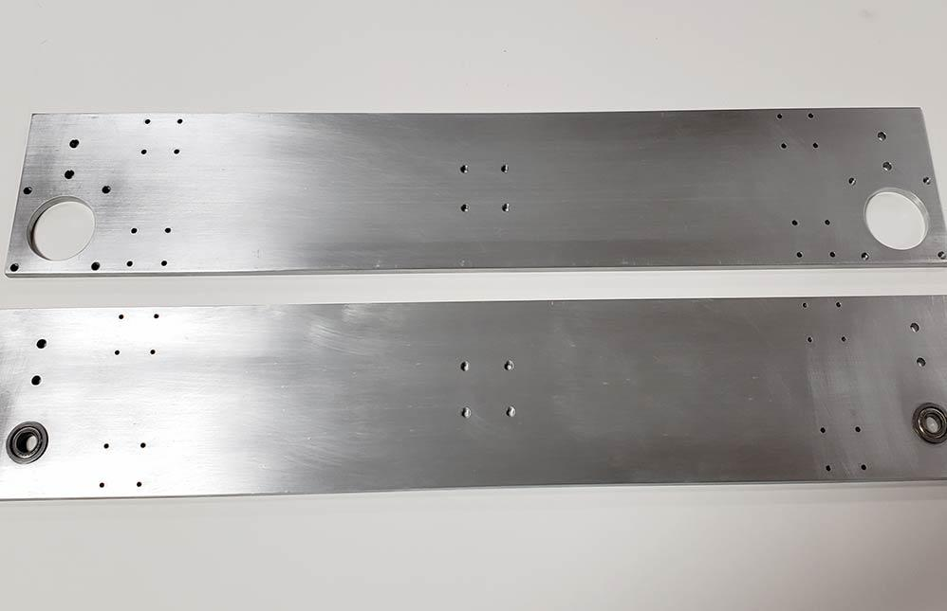WorkHorse 3D Printer Gantry Plates

Machined Hardware | Price $ | Source
4″ plate kit 2pcs w/bearings |  | 3DD
X- Axis C- Carriages 2pcs |  | 3DD
Y-Axis C- Carriage 1pc |  | 3DD
Y-Axis Motor Mount 1pc |  | 3DD
Y-Axis Idler Mount 1pc |  | 3DD
Hotend Mount |  | 3DD
Z-Axis Motor Mounts 2pcs |  | 3DD
Aluminum Bed
WorkHorse BOM

Duet3D Firmware Files
Download

Electronics
We now recommend the Duet 3 Mainboard 6HC electronics by Duet3D.

Build Instructions
Here
Share this:

3D Distributed
WorkHorse 3D Printer
Electronics | Price Each | Part Number | Pcs.
Nema 17 Stepper Motor Z-Axis | 17.95 | MO-N17-48-22B-3X | 2pcs
NEMA 23 269 oz.in X-Axis | 17.95 | MO-N23-76-21B | 2pcs
NEMA 23 184 oz.in Y -Axis | 17.95 | KL23H251-28-4A | 1pcs
Duet 3 Mainboard | Duet 3D |  | 1pcs
ARCOL / Ohmite HS50 300R F |  |  | 30
Omron Automation and Safety G3NA-220B-UTU AC100-120 |  |  | 1
Lead Screw | Price $ Each | Part Number | Description
Igus 761mm Long (X Axis) | $ 93.23 | DST-LS-10x50-R | DST-LS-10X50-R-ES
Igus 485mm Long (Y Axis) | $ 74.80 | DST-LS-10x50-R | DST-LS-10X50-R-ES
Igus Lead Screw Nuts | $ 35.78 | DST-JFRM-2525DS1  0X50 | Ds10x50
12mm T12x2 Trapezoidal ACME Lead Screw w/ Brass Nut
Total | $ 368.60
Linear Rails | Price $ Each | Discription | Source
450mm or 400mm Long w Y axis (1pc) | $ 61.95 | MGN12H 20mm x 20mm Hole Pattern | ZYLtech
700mm Long X Axis (2pc) | $ 29.95 | MGN12H 20mm x 20mm Hole Pattern | ZYLtech
500mm Long Z Axis (4pc) | $ 44.95 | MGN12H 20mm x 20mm Hole Pattern | ZYLtech
Total | $ 301.65
Total w/shipping + Tax | $361.17
Machined Hardware | Price $ | Source
Gantry Plates 2pcs w/bearings | $ 65.00 | 3D Distributed
X- Axis Carriages 2pcs | $ 44.80 | 3D Distributed
Y-Axis Carriage 1pc | $ 19.95 | 3D Distributed
Y-Axis Motor Mount 1pc | $ 15.50 | 3D Distributed
Y-Axis Idler Mount 1pc | $ 17.50 | 3D Distributed
Hotend Mount | $ 16.00 | 3D Distributed
Z-Axis Motor Mounts 2pcs | $ 37.50 | 3D Distributed
Aluminum Bed | $ 100.00 | 3D Distributed
Total | $ 316.25
Frame Extrusions | Length | Units | Description | Part #
HFS5-2020 | 930mm Long | 4pcs | Horizontals | HFS5-2020-930
HFS5-2020 | 510mm Long | 6pcs | Verticals | HFS5-2020-510
HFS5-2020 | 570mm Long | 10pcs | Widths | HFS5-2020-570
HFS5-2020 | 808mm Long | 3pcs | Bed Support | HFS5-2020-808
Gantry Extrusions | Length | Units | Description | Part#
HFS5-2040 | 770.5 Long | 2pcs | Gantry Horizontals | HFS5-2040-770
HFS5-2040 | 456Long | 1pcs
HFS5-2040 | 510 Long | 4pcs. | Z axis Linear Rail Verticals | HFS5-2040-510
Frame Components | Type | Units | Description | Part#
Frame Brackets | 20mm Wide | 90pcs | Reversal Tabbed Brackets | HBLFSNF5
Frame Brackets | M4 | 75pcs | M4 | HNKK5-4
Frame Brackets | M5 | 180pcs | M5 | HNKK5-5
Frame Brackets | M3 | 75pcs | M3 | HNKK5-3
Frame Price | Price $ | Estimated Shipping
Profile Extrusions | $ 122.29 |  | extrusions and backets w tax and shipping
M5 x 10 Cap Screws (200pcs) | $ 9.99 |  | 225$
brackets | $ 40.32
T-nuts | $ 19.32
T-nuts M3 (100pcs linear rail mounting) HNKK5-3 | $ 17.71 | 11.99
Total | $ 191.92

Related Content
3D Distributed
WorkHorse 3D Printer
SolidCore CoreXY 3D Printer
Duet3D
WorkHorse 3D Printer BOM
WorkHorse 3D Printer
WorkHorse CAD

3D Distributed
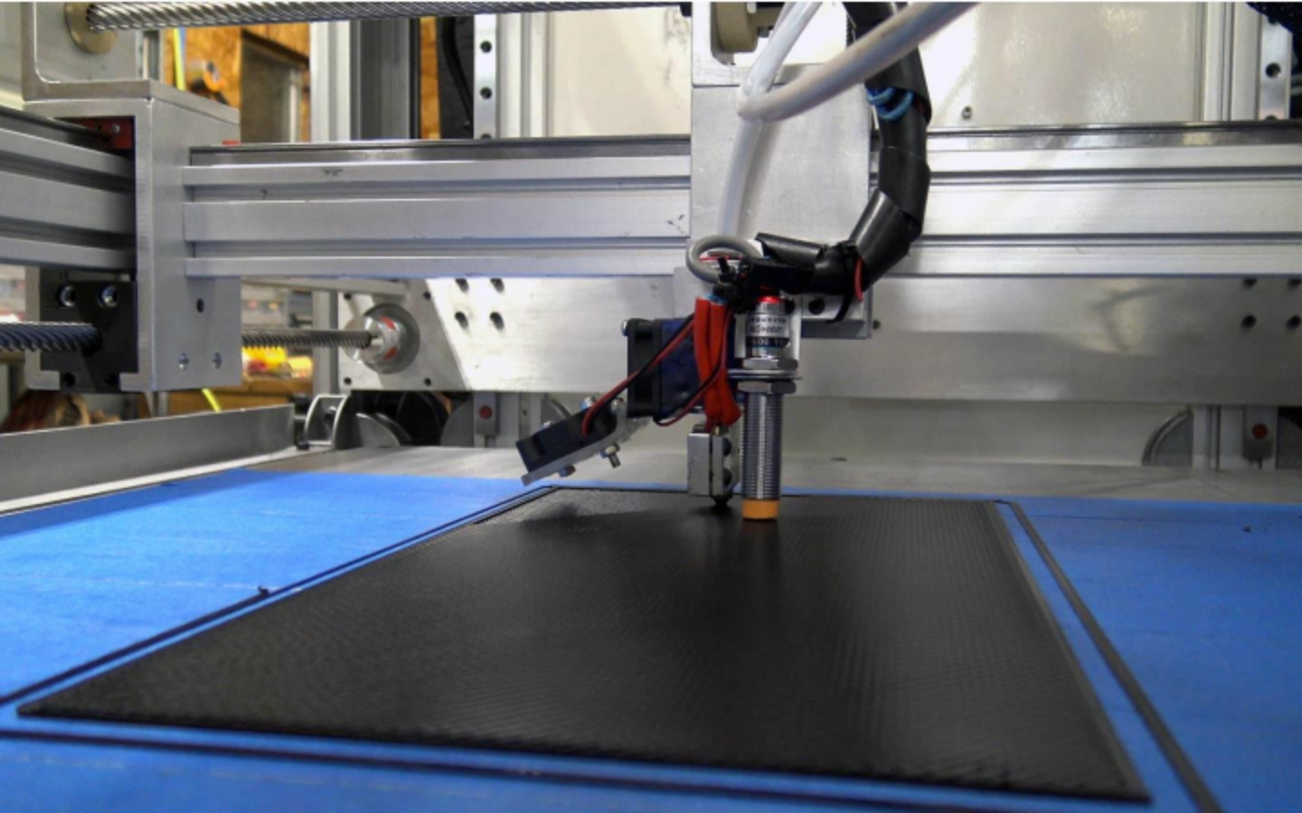
DIY 3D Printers
3D Printer Parts
3D Printer Kits
Large Scale 3D Printers
CoreXY
Midwest RepRap Festival
All Metal 3D Printer Parts
12601 Bowles Rd. Conroe, TX 77304

